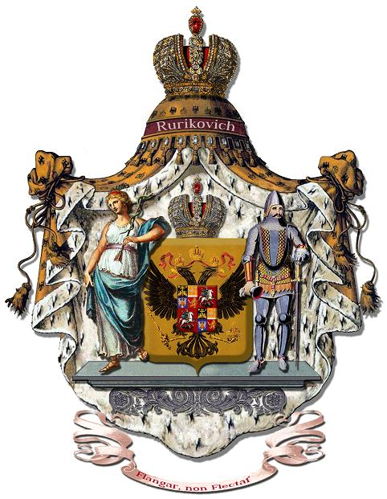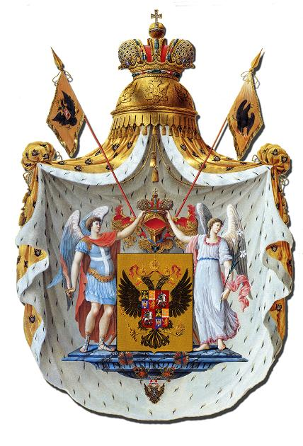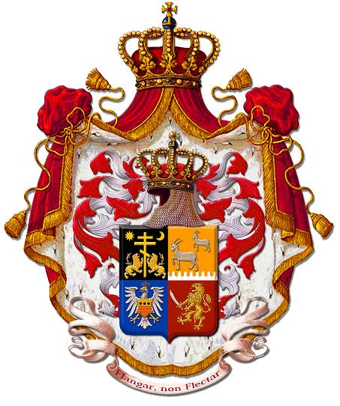
Soberana Casa Real e Imperial de Rurikovich
Gran Principesca y Gran Ducal
Dinastía Cabrera Rurikovich Kubarev
Note of protest to the Royal Household of HM the King of Spain
Grand Prince Valeriy Viktorovich Kubarev, the Sovereign August House Rurikovich and Fund ANRC of Princes declare the resolute protest to the Royal House of Spain and his heraldic management headed by Don Alfonso De Ceballos-Escalera, marquis De La Floresta in connection with promulgation of the missive from the August 30, 2010 signed
Don Alfonso.
In this letter Don Alfonso De Ceballos-Escalera, marquis De La Floresta in advantage of Grandee of Spain names of founders of Sovereign Imperial House Rurikovich comical and founders of the House sunk into dotage and unhealthy mentally.
Sovereign Imperial House Rurikovich is registered in independent Republic Argentina and does not submit to the Spanish legislation. Sneers of Don Alfonso at legal practice of Minister of Justice of Republic Argentina of Dr. Manuel Alberto Montero and sovereign activity of House Rurikovich are inadmissible intervention in our internal affairs.
Sovereign Imperial House Rurikovich is not ruling monarchs a dynasty, but restores historical validity and rights of the oppressed Princes of Sacred Russia Rurikovich, the deprived titles, the grounds and property Ivan Terrible, Romanov's House and a communistic mode of Russia.
Grand Prince Valeriy Viktorovich Kubarev Rurikovich, the Sovereign August House Rurikovich and Fund ANRC of Princes count happened annoying misunderstanding and demand bringing of official apologies from the Royal Household of HM the King of Spain for unworthy behavior of Don Alfonso De Ceballos-Escalera, marquis De La Floresta in advantage of Grandee of Spain.
Grand Prince of Sovereign Imperial House Rurikovich  Great Seneschal of Sovereign Imperial House Rurikovich  The President of Fund ANRC of Princes  Valeriy Viktorovich Kubarev Grand Kubensky Rurikovich  10.12.2010. | 